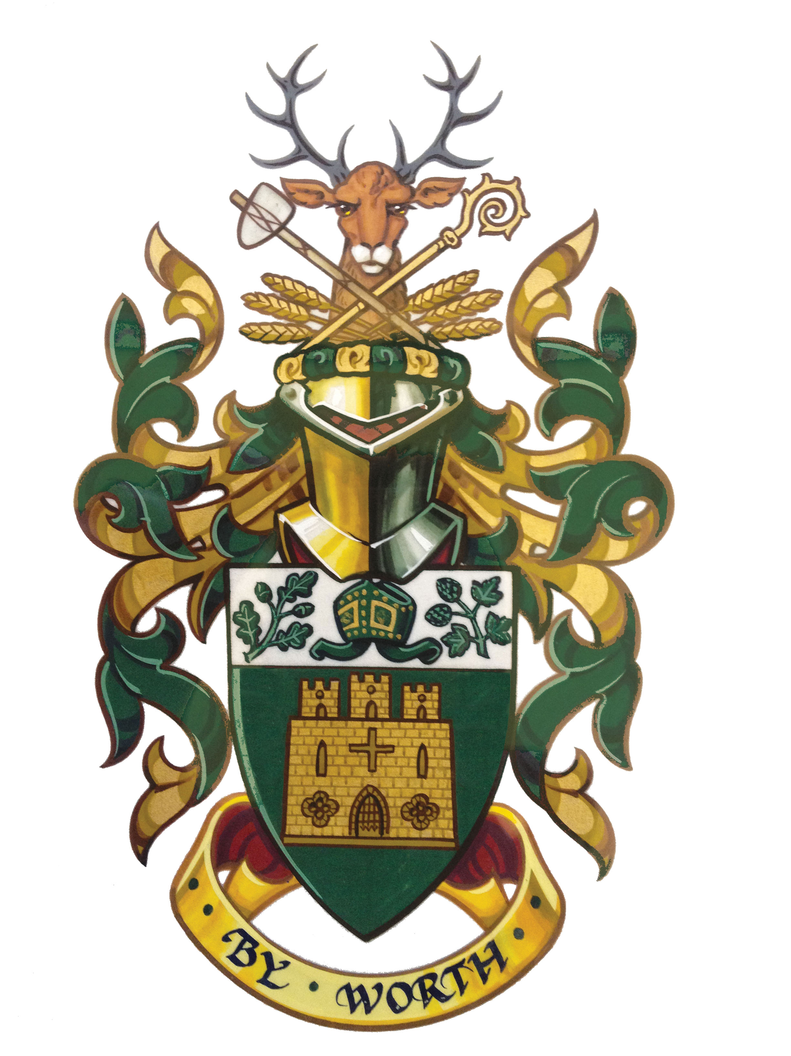

Farnham Town Council

Report and Financial Statements

Year ending 31st March 2024



Farnham Town Council

Financial Statements for the year ended 31 March 2024

Explanatory Foreword

Farnham Town Council’s Financial Statements for the year ended 31 March 2024 are set out on the pages attached and consist of the following:

- The Income & Expenditure Account, showing income and expenditure on all services.
- The Balance Sheet, setting out the Council’s financial position at the year end.
- Notes to the Accounts, providing information on amounts included in the statements.

This foreword provides a brief summary of the more important aspects of Farnham Town Council’s activities and its financial position.

Basis of preparing the Financial Statements

As the Council’s income is less than £6,500,000, the Council’s accounts follow the CIPFA Accounting Guidance for medium-sized councils. The balance sheet does not therefore need to include the value of fixed assets such as premises, equipment and infrastructure, although they are included for completeness. The cost of services excludes depreciation and the accounts also exclude adjustments that would be necessary to meet accounting standards relating to the accounting treatment for retirement benefits, as compliance is not required.

External Auditor’s Opinion

The External Auditor’s Opinion is provided on an Annual Governance & Accountability Return provided to the Council’s Auditors:

PKF Littlejohn LLP
Ref: SBA
2nd Floor
1 Westferry Circus
Canary Wharf
LONDON
E14 4HD

The figures provided in these statements are consistent with those provided in the Annual Governance & Accountability Return.

The Annual Governance & Accountability Return can be seen with the April 2024 Council Agenda and is also available online at www.farnham.gov.uk or on request from Farnham Town Council.

Farnham Town Council

Outturn for the Year ended 31st March 2024

The outturn for the year is set out in the Income & Expenditure Account on page 4 and may be summarised as follows:
 | £
Cost of services | 1,667,867
Income received | 503,171
Net spending | 1,174,695
Precept on Waverley Borough Council | 1,315,900
Amount transferred to balances for the year* | 141,205
*Includes Community Infrastructure Levy (CIL) contributions

Capital expenditure

The funding for capital expenditure in the 2023/24 year was all from revenue (including grants) and balances. There was no borrowing in the year.

Statement of responsibilities for the Statements of Accounts

The Council is required to:
- Make arrangements for the administration of its financial affairs.
- Ensure that one of its officers (referred to as the Responsible Financial Officer) is responsible for the administration of those affairs. At Farnham Town Council, that officer is the Town Clerk.
- Manage its affairs to secure economic, efficient and effective use of resources and to safeguard its assets.

The Responsible Financial Officer is responsible for preparation of the Council’s statements of accounts in accordance with the CIPFA Accounting Guidance so far as applicable to this Council, to present fairly the financial position of the Council at 31 March 2024 and its income and expenditure for the year then ended. In preparing the statements of accounts, the Responsible Officer has:
- Selected suitable accounting policies and applied them consistently;
- Made judgements that were reasonable and prudent; and
- Complied with the Guidance.

The Responsible Officer has also:
- Kept proper accounting records that were up to date; and
- Taken reasonable steps for the prevention and detection of fraud and other irregularities.

Councillor …..
Town Mayor (2023-24)
Farnham Town Hall
South Street
Farnham
Surrey GU9 7RN

Farnham Town Council

Income & Expenditure for the year ended 31 March 2024

 |  | Year ended 31 March 2024 |  |  | 2022/23
Expenditure by Working Groups |  | Expense | Income | Net | Net
 |  | £ | £ | £ | £
1 Strategy & Resources (excluding precept) |  | 736,122 | 210,205 | 525,917 | 409,483
2 Environment (including Cemeteries) |  | 584,760 | 150,174 | 434,586 | 527,401
3 Community |  | 331,530 | 112,903 | 218,627 | 185,951
4 Farnham Support Fund |  | 15,455 | 19,890 | (4,435) | 10,722
Net cost of services |  | 1,667,867 | 503,171 | 1,174,695 | 1,133,557

 |  |  |  |  |  |  |  | £ |  | £
Precept on the Borough Council |  |  |  |  |  |  |  | 1,315,900 |  | 1,231,570
Total Surplus/(Deficit) for the year |  |  |  |  |  |  |  | 141,205 |  | 98,013
Transfers to Earmarked reserves (grants received not yet spent, commitments and other provisions agreed by Council) |  |  |  |  |  |  |  | (106,157) |  | (98,473)
General Fund Surplus/(Deficit) for the year |  |  |  |  |  |  |  | 34,254 |  | (459)
(transfers to earmarked reserves from previous surpluses were made (Legal reserve (+£20k, elections +£4k, release of £2k enterprise 19, and minor roundings £38) the total |  |  |  |  |  |  |  | 21,962
Movement on General Fund (Net surplus) |  |  |  |  |  |  |  | £12,292
 | Movement on General Fund balance and Earmarked reserves:
Balance brought forward |  |  |  |  |  |  |  | 2,014,359 |  | 1,916,346
Surplus/Deficit for the year (prior to transfer of CIL, Section 106 funding, Support Fund and agreed earmarked reserves) |  |  |  |  |  |  |  | 141,205 |  | 98,013
Balance carried forward |  |  |  |  |  |  |  | 2,155,564 |  | 2,014,359

Farnham Town Council

Balance Sheet at 31 March 2024

 | Notes | 31 March 2024 |  | 31 March 2023
 |  | £ | £ | £ | £
Fixed assets
Tangible fixed assets | 1, 3 |  | - |  | -

Current assets
Money Market deposits and other savings |  | 2,114,439 |  | 2,047,620
Debtors (including VAT recoverable) | 4 | 67,703 |  | 89,293
Bank/Petty cash |  | 96,558 |  | 70,560
Mayor’s charity funds held by council*  (Actual sum ££520 after monies paid by FTC to charities are transferred). |  | 3,471 |  | 2,418
Total current assets |  |  | 2,282,171 |  | 2,209,891

Current liabilities
Creditors and accrued expenses including commercial card and Mayor’s charity funds | 5 |  | 126,607 |  | 195,532
Total assets less current liabilities |  |  | 2,155,564 |  | 2,014,359

Capital and reserves
Earmarked Reserves | 6 |  | 1,649,799 |  | 1,520,886
General Reserves |  |  | 505,765 |  | 493,473
Total reserves |  |  | 2,155,564 |  | 2,014,359
The Council had an outstanding Public Works Loans Board (No 478388) repayable on an annuity basis until 29/10/22. This was repaid in full during 2019/20.  The amount outstanding is: |  |  | £NIL |  | £NIL

The Notes on pages 6 to 10 also form part of the Financial Statements.

The Council falls within the Audit Commission’s ‘lighter touch’ audit regime and so the external audit opinion is provided on the Annual Return, which includes a summary of the Income and Expenditure Statement and Balance Sheet.

The above statement presents fairly the financial position of the Council as at 31 March 2024 and reflects its income and expenditure for the year. These Financial Statements reflect statements that were approved at a meeting of the Council held in April 2024.

......................................... .........................................

Town Mayor 2023-24 Responsible Financial Officer

Farnham Town Council

Notes to the Financial Statements for the year ended 31 March 2024

- Principal accounting policies

Accounting convention
The Financial Statements have been prepared in accordance with the CIPFA Accounting Guidance for Local Councils, which is recognised by statute as representing proper accounting practices, as applied to the accounts of local councils.

Fixed assets
The Council’s Financial Statements are not required to include the value of fixed assets on the balance sheet or depreciation in the Income & Expenditure Account. The acquisition, creation or enhancement of fixed assets is charged to revenue each year, and disposal proceeds are credited to a capital receipts reserve if not immediately used to fund capital expenditure.

Fixed assets are valued in the Notes to the Financial Statements on the bases recommended by CIPFA and in accordance with the statements of asset valuation principles set out in ‘Governance and Accountability – A Practitioners’ Guide’ and guidance notes issued by the Royal Institution of Chartered Surveyors (RICS). The closing balances are stated on the following basis:

- Land, operational properties and equipment, infrastructure and community assets are valued at the original purchase price, or the value at first recording of the asset. These values remain unchanged until disposal.
- Certain community assets are the subject of restrictive covenants as to their use and/or future disposal. Assets considered to have no appreciable realisable value are recorded at their historic cost value or given a £1 nominal value.

At the end of the 2013-14 financial year, the assets were reviewed and restated in line with the latest guidance issued by the external auditor with assets previously listed to include proxy values, being revalued to zero (for gifts) or £1 for assets transferred from another authority.

Debtors and creditors
The Council’s Financial Statements are maintained on an accruals basis. Amounts due to or from the Council during the year are included whether or not the cash has actually been received or paid in the year.

Stocks and work in progress
Stocks of office supplies and for grounds maintenance have been treated as consumed because their value was not material.

Reserves
The Council maintains certain operational reserves to meet general and specific future expenditure. The purpose of the Council’s reserves is explained in Note 6.

General administration and support service costs
Central administrative support costs are reallocated direct to the services concerned, so far as they can reasonably be ascertained. The remaining administrative costs, including those relating to the democratic process, are shown as a separate service cost in the Income & Expenditure Account.

Farnham Town Council
Notes to the Financial Statements for the year ended 31 March 2024 (continued)
- Pension costs

The Council’s staff members are eligible to become members of the Surrey Superannuation Fund, which is administered by Surrey County Council and are auto-enrolled into the scheme as required.

The pension costs that are charged to the Council’s accounts in respect of its employees are equal to the contributions paid to the funded pension scheme for these employees. These contributions are determined by the Fund’s actuary on a triennial basis and are set to meet 100% of the liabilities of the Fund, in accordance with relevant government regulations. The latest triennial review was in 2022.

- Fixed assets (following revaluation 31st March 2014 in line with external auditor’s latest guidance) | 31st March 2024 | 31st March 2023
Operational land and buildings (on historic cost basis) | £ | £
Council Offices  Other Public Buildings | 270,568  422,719 | 270,568  422,719
Wrecclesham Community Centre | 206,110 | 206,110
Depot | 146,830 | 143,058
Vehicles and equipment
Vehicles  Audio and Visual Systems | 127,383  42,541 | 127,383  35,453
Christmas Decorations  Civic Insignia  Grounds Equipment  Computers, telephones and office equipment  Other | 113,285  14,814  145,891  95,821  47,142 | 113,285  14,814  137,113  91,671  27,017
Infrastructure assets  Bus shelters  Town Centre CCTV  Boards and Signs  Street furniture (Litter bins, lampposts, Seats) | 70,598  104,845  15,277 21,879 | 70,598  104,845  15,277 21,879
Community assets
Cemeteries | 679,634 | 676,121
Allotments and Gardens | 83,769 | 83,769
Long-term investments
CCLA Local Authorities Property Fund | 250,000 | 250,000
Total value | 2,859,106 | 2,811,680

Farnham Town Council
Notes to the Financial Statements for the year ended 31 March 2024 (continued)

- Debtors and prepayments | 2024 | 2023
 | £ | £
Debtors | 23,146 | 26,556
Value added tax | 43,630 | 62,737
Pension debtor | 0 | 0
Prepayments | 927 | -
 | 67,703 | 89,293
- Creditors and accrued expenses | 2024 |  | 2023
 | £ |  | £
Creditors | 48,660 | 51,631
Pensions/PAYE/NIC creditor | 15,080 | 10,099
Income in advance | 16,356 | 23,170
Accruals | 38,237 | 102,101
HSBC Commercial Card | 7,754 | 5,640
Mayor’s charity funds held by Council | 520 | 2,892
 | 126,607 |  | 195,532

- Earmarked Reserves and General Reserves

Category | Balance at 31.3.24 | Comments
Election/By-election Fund | £55,000 | Election/By-election costs. WBC invoices after an election.
Legal Expense fund | £50,000 | To cover unforeseen legal costs above revenue provision.
New Equipment | £50,000 | Planned equipment upgrades including vehicles.
Wrecclesham Community Centre | £50,000 | Provision for unforeseen expenditure of FTC asset.
Street Furniture | £20,000 | Infrastructure to be developed.
SCC Bus Shelter Refurbishment | £8,000 | Commuted sum from SCC for bus shelter refurbishment
Gostrey Meadow/public space enhancements | £65,000 | Includes upgrades and bandstand.
CCTV and Crime Prevention | £52,450 | To fund programmed investment.
Environment | £75,000 | Provision for environmental initiatives
Cemetery Chapels and Enhancements | £76,750 | Major repairs required for the FTC owned Chapels.
Hale Cemetery Lychgates | £20,000 | To fund the repair of the cemetery lychgates
IT investment | £25,000 | To fund required investment/ upgrades.
Tourism Development | £20,000 | To fund improved services.
Public Conveniences | £210,000 | Upgrade to improve public conveniences including Gostrey Meadow & the Hart
Town Hall | £100,000 | Unforeseen/emergency repairs provision
Sub-total | £877,200

Farnham Town Council
Notes to the Financial Statements for the year ended 31 March 2024 (continued)

Total Earmarked (bfwd from previous page | £877,200
Christmas Lights | £55,000 | To fund the purchase of future Christmas Lights
Capital Receipts | £80,000 | This comprises capital receipts arising from the disposal of fixed assets less expenditure on new capital items.
World Craft Town | £25,000 | To fund expenditure related to World Craft Town activities
CIL - unallocated | £156,041 | Community Infrastructure Levy receipts received and not yet spent or earmarked
CIL – Gostrey Meadow | £200,000 | Community Infrastructure Levy receipts receipts received and earmarked for use at Gostrey Meadow
CIL – Town Centre Improvements | £50,000 | Community Infrastructure Levy receipts receipts received and earmarked for use for Town Centre Improvements
CIL - Farnham Museum | 10,000 | Pledge to improve visitor experience
Wrecclesham s106 | £6,199 | The unspent balance of s106 receipts for landscaping at Wrecclesham and for Wrecclesham Gateway project
West St Railings s106 | £27,144 | The unspent balance of a s106 receipt for work currently underway on the West Street Railings project.
UCA s106 | £12,673 | The unspent balance of a s106 receipt.
Youth Facilities | £25,000 | To fund expenditure on facilities for young people
Farnham Support Fund | £16,809 | The unspent balance of the Farnham Support Fund as at 31st March 2024
Business Improvement | £15,000 | To support emerging business support activities including the Business Improvement District
Farnham Flame | £8,500 | To fund the Farnham Flame sculpture
Greenhouse | £55,233 | Insurance claim receipts set aside for the development of the greenhouse facilities
Neighbourhood Plan | £30,000 | To fund revisions to the Neighbourhood Plan
Total Earmarked Reserves | £1,649,799
General | £505,765 | FTC Policy is that general reserves be 50% of the total annual precept or operating expenditure. As a large Council with good earmarked reserves this figure can be lower and it represents 36% of the 2024-25 precept
Total Reserves | £2,155,564

Farnham Town Council
Notes to the Financial Statements for the year ended 31 March 2024 (continued)

- Contingent liabilities

There were no contingent liabilities at 31 March 2024 (2023: none).

- Grants paid in the year

During the year Community grants were paid to the following organisations:
Community Grants: | £
1st Rowledge Guides | 500
Badshot Lea Tennis Club | 1,000
Blackwater Valley Countryside Partnership | 2,500
Boom Credit Union | 15,000
Disability Challengers | 1,000
Farnham Art & Design Education Group | 500
Farnham Assist | 750
Farnham Carnival | 2,000
Farnham Community Farm | 450
Farnham Repair Café | 500
Farnham Sports Council | 450
Farnham Support Fund | 5,000
Farnham Youth Choir | 5,200
Frensham Pond Sailability | 1,000
Friends of Rowledge School | 625
Hale Carnival Committee | 1,000
Helen Arkell Dyslexia Centre | 1,000
Hive Helpers CIC | 500
Homestart | 1,000
I Chose Freedom | 2,000
Kind to mind | 500
New Ashgate Gallery | 1,000
Rotary Club of Farnham Weyside | 1,200
Rowledge Tennis Club | 1,000
Sight for Surrey | 500
Space2grow | 4,000
University for the Creative Arts | 500
Weydon School | 1,500
 | 52,175
In addition, grants for services provided were made to: | £
40 Degreez | 8,000
Brightwells Gostrey Centre | 5,000
Citizens Advice Bureau | 20,000
Farnham Maltings | 10,000
Hale Community Centre | 7,000
Waverley Hoppa | 10,000
 | 54,000

Farnham Town Council
Notes to the Financial Statements for the year ended 31 March 2024 (continued)

Town Clerk Small Grants | £
Folly Hill Infants School | 250
Phyllis Tuckwell Hospice | 200
Post19 allotment grant | 60
RBL hire of Gostrey Meadow VE/VJ commemoration | 250
Scouts – loan of gazebo | 40
St Andrew’s School allotment grant | 60
Wrecclesham Village Fete | 250
 | 1,110

