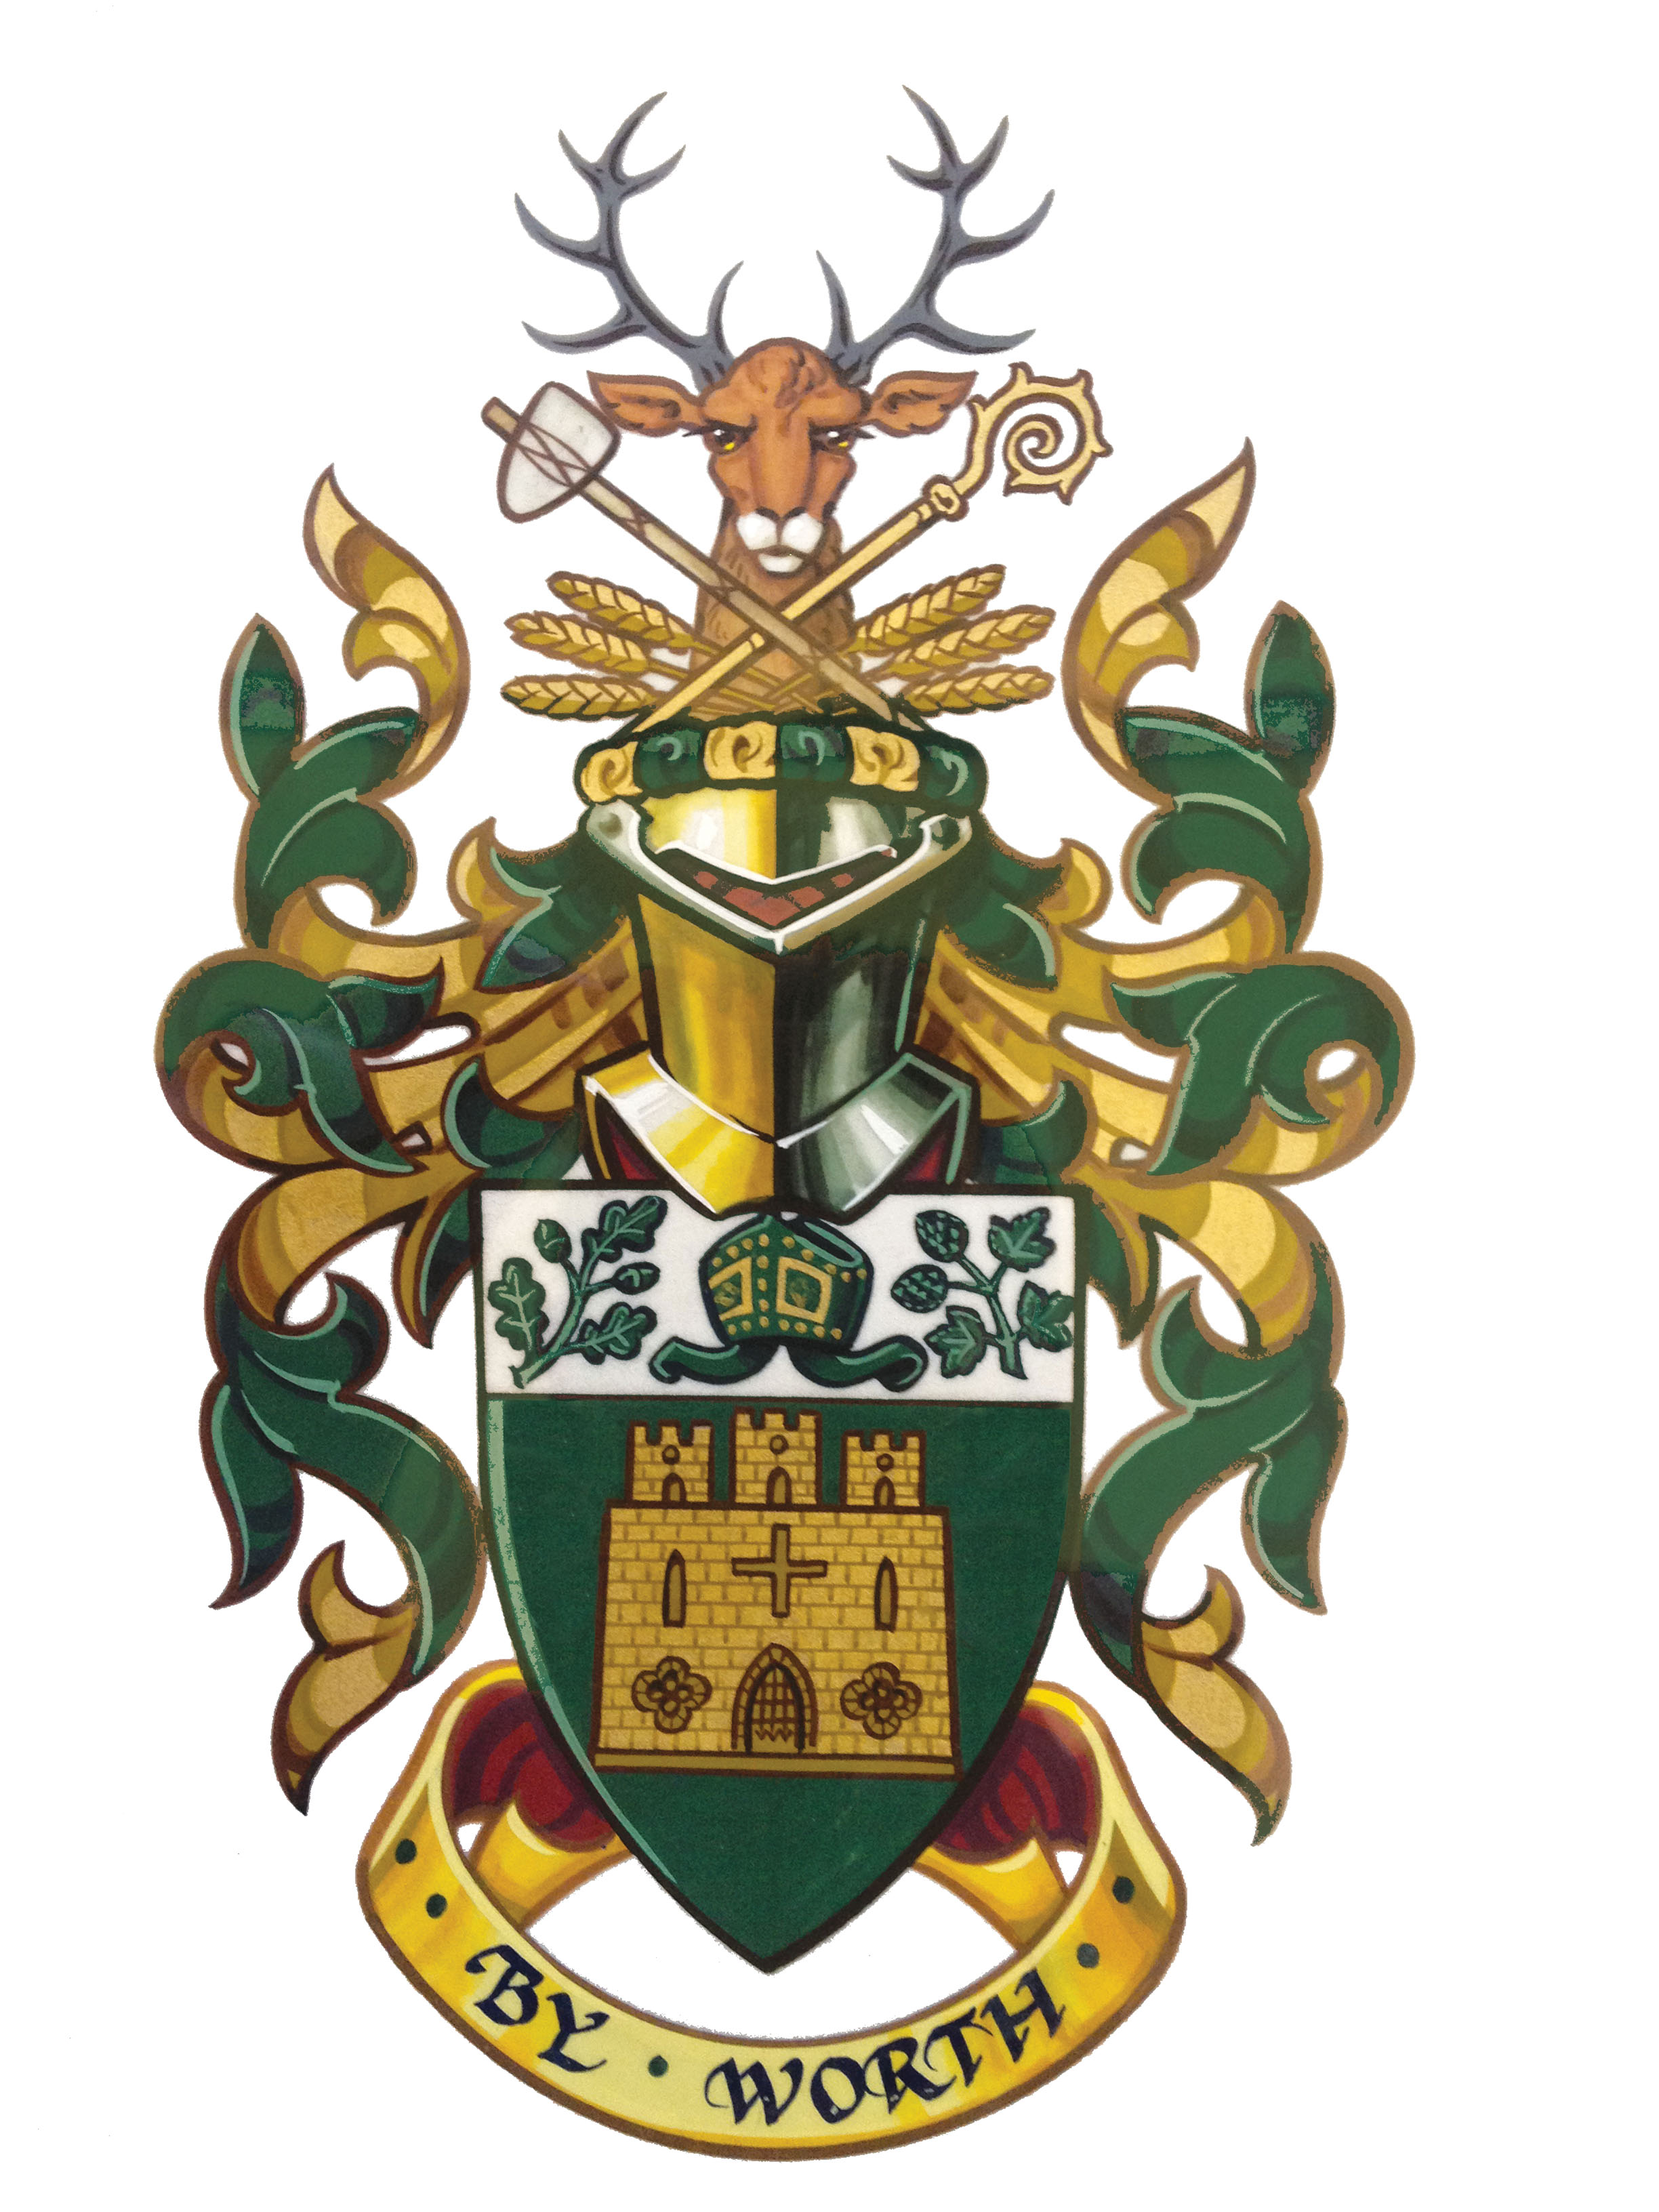
Farnham Town Council
Mayoral Invitation Form 2022-23

The Mayor of Farnham: Councillor Alan Earwaker  The Mayoress: Mrs Claire Earwaker dos Reis  Deputy Town Mayor: Councillor Michaela Wicks | Please return to:  Farnham Town Council  South Street, Farnham GU9 7RN  Tel: 01252 712667  (calls may be recorded for monitoring)  Email: mayor@farnham.gov.uk
Please complete electronically or in block capitals
Name of Organisation:

Event: Community
Is the Mayoress invited to accompany the Mayor? Yes/No
Are you happy for this invitation to be listed on the Farnham Town Council website? Yes / No
Or mentioned on the Mayor’s Facebook and Twitter accounts Yes / No

Date: | Arrival time: Start Time of event: | Finish Time:

Address of venue:

Post Code:

Reserved car parking on site? If no reserved parking, please indicate nearest available car park.
Yes /

Would you like the Mayor to perform any special duties? (e.g. cutting ribbon, presenting awards, making a speech)

Dress Code (day)  Would you like the Mayor to wear the chain of office? Yes / No  (normally the Mayor would wear the chain of office unless the event were informal and you specifically request ‘no chains of office’.) | Will Refreshments be provided?

Title, name and position of person meeting the Mayor: |  | Contact telephone number on day of the event:
Correspondence Postal Address: (for future correspondence)

Post Code:
Tel: | Mobile: | E-mail:

Details of other Mayors / VIPs attending and duties they will be performing if appropriate.

Please Note: In speeches the Mayor is referred to as ‘Mr Mayor’.
If formal photographs are taken at the event, a copy would be appreciated for the Mayor’s portfolio.

