**To Future Surrey County Councillors!**

**Prospective Councillors’ Event**

You will hear from our Chief Executive, David McNulty, on the council’s recent achievements and Surrey’s priorities for the future and there will be a question time with experienced councillors.

It is also an opportunity to meeting with the current political groups and get a flavour of the work of the Council at our market place.

We will be running tours of the meeting rooms and councillors’ facilities at County Hall

**Saturday 17 October**

*9.30 – 14.00 – Ashcombe Suite and Grand Hall, County Hall, Kingston upon Thames*

**Tuesday 3 November** *15.00-19.30 – Ashcombe Suite and Grand Hall, County Hall, Kingston upon Thames*

Ahead of the 2017 local elections, Surrey County Council’s Democratic Services are offering those interested in standing for election a chance to understand more about the role of a County Councillor and the work of the council. All are welcome, whether you intend to stand as a candidate for a political group, or as an independent, or simply wish to know more about the process and what the role involves.

**If you are interested in attending please get in touch BY 9 OCTOBER 2015 via our online RSVP website for one of the following dates:**

Saturday 17 October: Click here to register: <https://www.eventbrite.co.uk/e/prospective-councillors-event-tickets-18842896611>

Tuesday 03 November: Click here to register: <https://www.eventbrite.co.uk/e/prospective-councillors-event-tickets-18860583513>

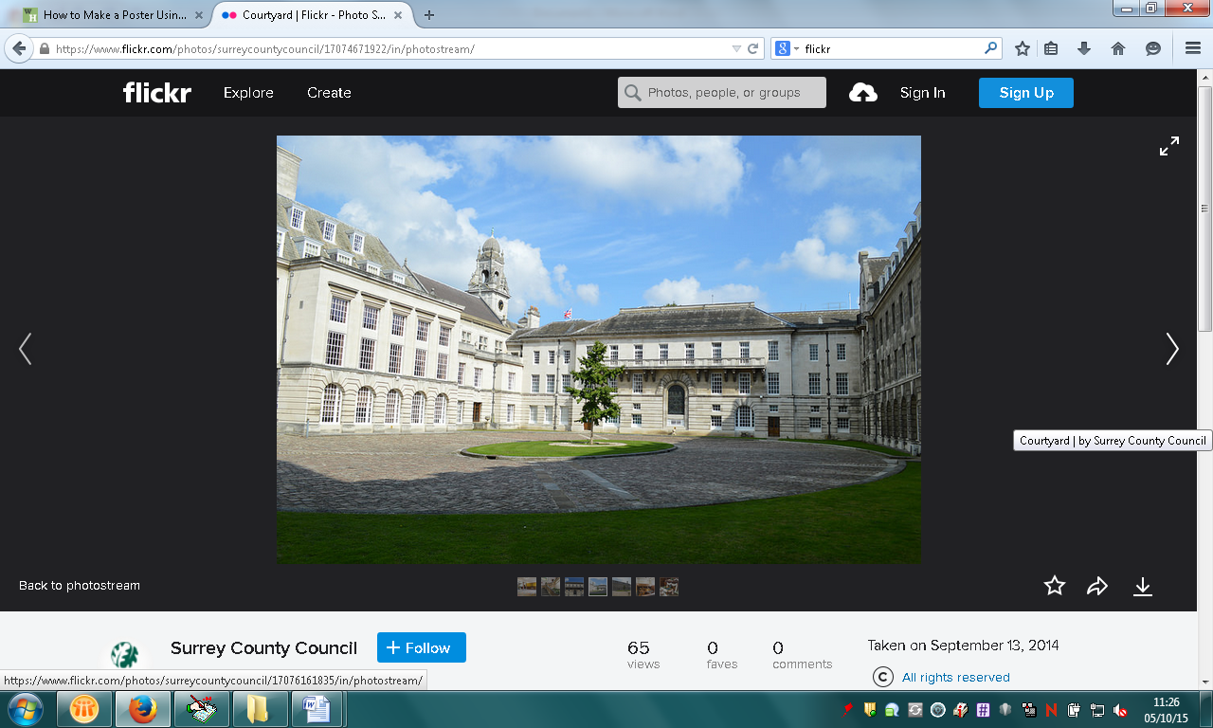

**Please contact Democratic Services with any questions:**

[**democratic.services@surreycc.gov.uk**](mailto:democratic.services@surreycc.gov.uk) **or 020 8541 9122**