To Future Surrey County Councillors!

Prospective Councillors’ Event
You will hear from our Chief Executive, David McNulty, on the council’s recent achievements and Surrey’s priorities for the future and there will be a question time with experienced councillors.
It is also an opportunity to meeting with the current political groups and get a flavour of the work of the Council at our market place.
We will be running tours of the meeting rooms and councillors’ facilities at County Hall
Saturday 17 October
9.30 – 14.00 – Ashcombe Suite and Grand Hall, County Hall, Kingston upon Thames

Tuesday 3 November 15.00-19.30 – Ashcombe Suite and Grand Hall, County Hall, Kingston upon Thames
Ahead of the 2017 local elections, Surrey County Council’s Democratic Services are offering those interested in standing for election a chance to understand more about the role of a County Councillor and the work of the council. All are welcome, whether you intend to stand as a candidate for a political group, or as an independent, or simply wish to know more about the process and what the role involves.

If you are interested in attending please get in touch BY 9 OCTOBER 2015 via our online RSVP website for one of the following dates:
Saturday 17 October: Click here to register: https://www.eventbrite.co.uk/e/prospective-councillors-event-tickets-18842896611
Tuesday 03 November: Click here to register: https://www.eventbrite.co.uk/e/prospective-councillors-event-tickets-18860583513

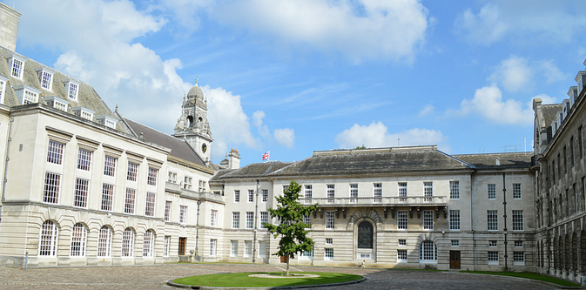

Please contact Democratic Services with any questions:
democratic.services@surreycc.gov.uk or 020 8541 9122

